Slide.Show 2 Quick Start Guide
Vertigo Software
October 2008
Contents
Introduction 1
Your first slideshow with Slide.Show 2 1
Step 1: Embed the control 2
Step 2: Configure the control 3
Step 3: Provide data to the control 3
Where to go from here? 5

Introduction
This guide has one purpose – to help you build your first slideshow with Slide.Show 2 as quickly as possible. It assumes that your scenario is typical – you have a nice collection of photos that you’d like to display on your personal Web site.
Of course, Slide.Show 2 was designed with flexibility in mind, whether it’s embedding Flickr photos directly in a blog post, displaying a line of products using the corporate colors and a watermark, or even providing a fluid, theater-like viewing experience for high-resolution artwork.
But that’s not what this guide is about. Once you’re familiar with the basic steps and tips below, you’ll be ready to customize, extend, and embed your slideshows anywhere on the Web. But first, the basics…

Your first slideshow with Slide.Show 2
The typical scenario involves the following steps:
- Determine the Web page to host your slideshow
- Define the configuration for the desired behavior and options for the control
- Define the data with the album and slide data for the control

Step 1: Embed the control
At a minimum, a Web page hosting the Slide.Show 2 control requires the following:
- An object tag for displaying the control
- A parameter specifying the style, behavior, and data for the control
- A parameter referencing the Vertigo.SlideShow.xap file
Tip: To keep things organized, create a new folder in your site to contain the page and other files required by your slideshow, including the Slide.Show 2 XAP file, configuration and data files, images, and videos.
First, create a new page in your site with the following content:
<html>
<head>
<title>Slide.Show 2 Quick Start Example</title>
</head>
<body>
<object type="application/x-silverlight-2" data="data:application/x-silverlight-2,"
width="640" height="480">
<param name="background" value="black" />
<param name="source" value="Vertigo.SlideShow.xap" />
<param name="initParams" value="" />
</object>
</body>
</html>

We have set up a new slideshow with a width of 640, height of 480, and a black background. We are specifying the path to the Slide.Show 2 XAP file (Vertigo.SlideShow.xap). At this point, it’s just an empty slideshow as shown below:
Figure 1. An empty slideshow
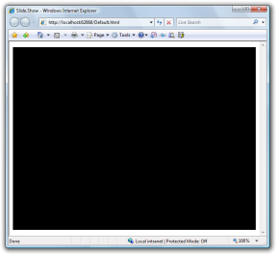
Note: The object tag will embed the Slide.Show 2 control in the HTML document at the exact location of the object tag (e.g. within table cells, div tags, etc.). This is important to note when integrating the control with complex page layouts.

Step 2: Configure the control
To give substance to your empty slideshow, you’ll need to configure it. In this scenario, we will be applying the configuration using one of the out-of-the-box themes provided by Slide.Show 2. A theme is a set of configuration values that achieve an overall look and feel. The available themes are: SimpleTheme, LightTheme, and DarkTheme.
First, modify the initParams of the object tag as follows:
<param name="initParams" value="ConfigurationProvider=LightTheme"/>
Note: Slide.Show 2 can be configured via theme or an XML file. The latter allows detailed configuration of your slideshow.

Step 3: Provide data to the control
In the previous step, we configured the look and feel of the Slide.Show 2 control. In this final step, we’ll provide album and slide data to the control via an XML data file.
First, modify the initParams of the object tag as follows:
<param name="initParams" value="ConfigurationProvider=LightTheme,DataProvider=XmlDataProvider;Path=Data.xml"/>
Tip: Alternatively, Slide.Show 2 can be configured to use a different data provider, such as the FlickrDataProvider, which uses the Flickr API to retrieve photo data for a given Flickr user.
Next, create a file named Data.xml containing the following markup:
<data transition="CrossFadeTransition">
<album
title="Album Title #1"
description="Album Description #1"
source="Images/Album1.jpg">
<slide
title="Slide Title #1"
description="Slide Description #1"
source="Images/Slide1.jpg"
thumbnail="Images/Thumbnail1.jpg" />
<slide
title="Slide Title #2"
description="Slide Description #2"
source="Videos/Slide2.wmv"
thumbnail="Images/Thumbnail2.jpg" />
…
</album>
…
</data>
Obviously, your data file should be modified to contain real album and slide data specific to your slideshow. Once it’s complete, reload the page in the browser and enjoy your slideshow!
To use Slide.Show 2 to view your Flickr photos, modify the initParams of the object tag as follows:
<param name="initParams" value="ConfigurationProvider=LightTheme,DataProvider=FlickrDataProvider;UserName=[username];ApiKey=[apikey]" />
Be sure to replace [username] and [apikey] with your Flickr username and API key.
Note: Vertigo have set up a global Flickr API key which can be used by any developer implementing Slide.Show 2. It is:
b45329018eafdf2a4f89ebf6fb2bf47a

Figure 2. The finished slideshow
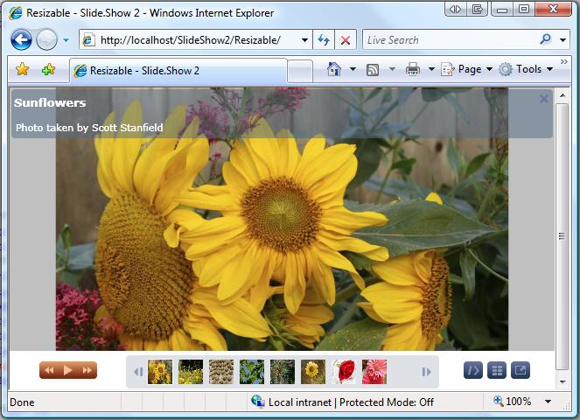
Tip: The data file may reference local or remote images and videos using relative or absolute URLs. JPEG and PNG image format is supported.
If using relative paths for source material such as videos and images, the paths are relative to the location of the XAP file.

Tip: Although Slide.Show 2 works well with a single set of images, you can optimize performance and improve the sharpness of smaller images in your slideshow by creating additional sets of images sized specifically for use by albums, thumbnails, and thumbnail previews.

Slide.Show 1 migration
Slide.Show 1 data files can be reused with Slide.Show 2 without change. However, Slide.Show 2 configuration options are different than Slide.Show 1 configuration options. You will need to port your existing configuration files. Our recommendation is to use a theme. Please see the Slide.Show 2 Configuration Guide for additional guidance.

Where to go from here?
Now that you’re familiar with the basic steps and tips listed above, please refer to the additional documentation available in the source code or the Slide.Show 2 Configuration Guide for detailed information about extending Slide.Show 2 to meet your unique needs.

See the Slide.Show 2 Configuration Guide for details on how to manually configure the look and feel of your slideshow using XML configuration. Slide.Show 2 supports over 200 configurable options!

